Tasks | Projected Time(minutes) | Actual Time needed(minutes) | Status
Understanding the project Requirements | 30 | 30 | (100%)Done
- Setting up MYSQL JDBC connection environment in netbeans and creating connection class.  2. Importing English dictionary Database to netbeans services. | 30 | 70 | (100%)Done
- Creating HTML  - Writing JavaScript  - Creating the servlet class | 120 | 180 | 100%(Done)
Creating fancy CSS | 60 | 60 | 100%(Done)
Debugging the code and cleaning the code/Finalized version of code | 10 | 10 | 100%(Done)
Project:English Dictionary

Screen-shots:
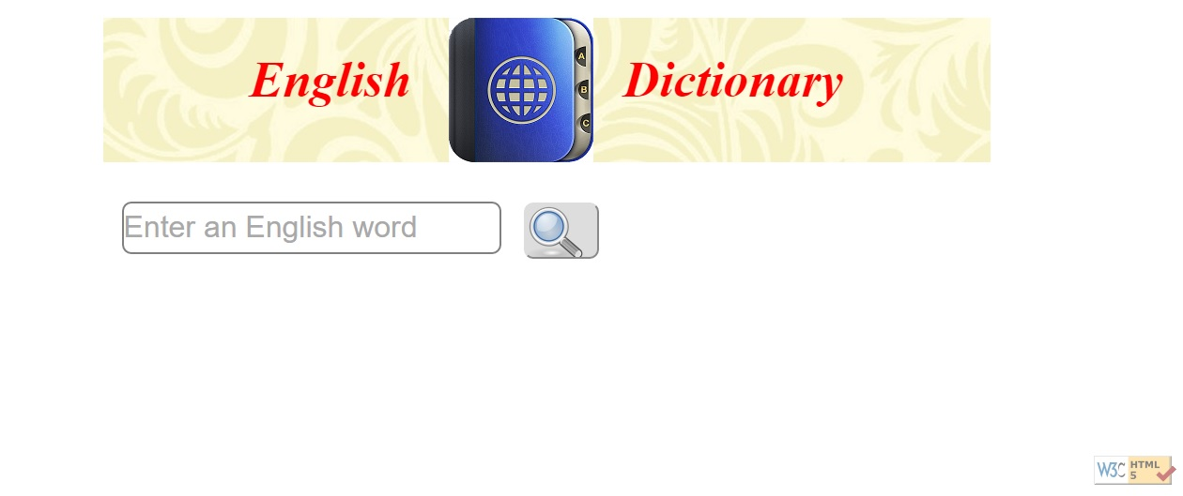
Fig1:Home screen
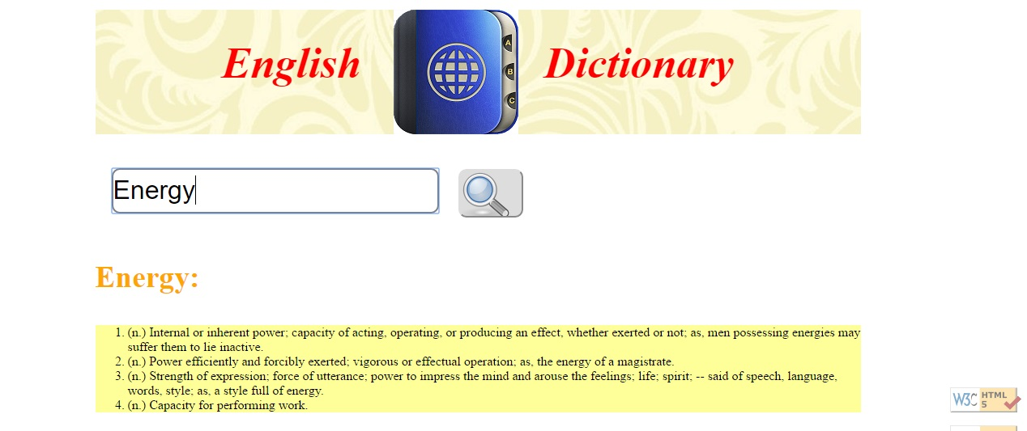

Fig2:After searching any word meaning

